# Total Points Gradebook setup 2015-16 school year

|  |  |  |  |  |  |
| --- | --- | --- | --- | --- | --- |
|  | | | | To open Campus Instruction,  1.) click the “***app switcher***”  &  2.) select “***Campus Instruction”*** in the menu that opens: | |
|  | | | | |
| 3.) Click on ***Grade Book.***  4.) Choose the correct ***Section*** (class) and be sure the ***Task*** is **Q*uarter Grade***  5.) Then click on the expansion arrows entitled ***Settings***: | | | | |
|  | You will get a screen that looks like the one on the left:  6.) Click on “***Categories***” | | | |
|  | | | 7.) Click on the ***Add*** button. | | |
|  | | 8.) Fill in the ***Name***,  ***Weight***  (if you do total points - leave this part alone – with the 0.0 in it.)  and ***Sequence*** (the order you want  the categories to appear on reports, on the spreadsheet in your gradebook, etc…)  Click the sections you wish to include. | | | |
|  | | | 9.) Check the ***Term – Quarter Grade***  10.) Click the ***Save*** button  Note – IF you use just one category named “Grades” then you can also add the category to the “Semester Test” Grading task and save yourself some steps later on.  If you use multiple categories repeat steps 7-10 for each category. | | |

# To set the grading scale for your classes, you need to go into each section to do this:

|  |  |  |
| --- | --- | --- |
|  | 11.) click on the expansion arrows entitled  ***Settings***: | |
|  | You will get a screen that looks like the one on the left  12.) Click on “***Grade Calc Options***” | |
|  | | 13.) Click “***continue***”  Note - You may only get this screen in your first class. |
|  | | 14.) Click the down arrow below “***Fill Calculation Type***”  15.) Select “***In Progress Grade***”  This will open up the “***Grading Scale***” option |
|  | | 16.) Choose “***Riggs (5 Letters)***”  This action should put those two choices beside  1 Quarter Grade  2 2nd Quarter Mid term  And as you scroll  2 Quarter Grade  2 Semester Grade  2 Semester Test Grade.  17. Click the “***Save***” button.  REPEAT steps 11-17 for each class / each section both 1st and 2nd semester. |

If you would like to Copy your categories from the 1st class you set up to a different class, then follow the steps #18-24

|  |  |  |  |
| --- | --- | --- | --- |
|  | 18.) click on the expansion arrows entitled  ***Settings***: | | |
|  | You will get a screen that looks like the one on the left:  19.) Click on “***Category Copier***” | | |
|  | | | 20.) On the left find the section that you wish to copy “FROM”  Below the selection you should find the categories listed (Daily Participation, Quizzes / Test, Performances / Readings).  21.) Then find the section you would like to copy “to”….  22.) And click “Next” button |
|  | | 23.) Check that you are copying the categories you would like to the “Quarter Grade”  24.) Click “Copy” Button | |

## Creating a Semester Test Category

1. . Be in “Grade Book”. 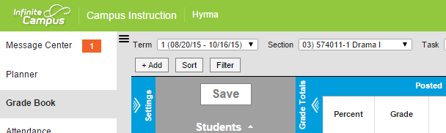

2. Click on the “***Settings***” expansion arrows: which gives you this dialog box:

|  |  |
| --- | --- |
|  | 4. Click on the “Categories” menu  . |
|  | This action will give you a list of the categories that you created for 1st and 2nd or 3rd and 4th quarters  5. Click the “***Add”*** button. |
|  | Create a new Category called  “Semester Test”  Leave the weight and the sequence as is  Under Category Placement  6. choose all the sections by clicking the box next to Term (or click each box individually)  Scroll down as you need to  Under Grading Task  7. Click Semester Test  8. Click the “Save” button |

## Creating a Semester Test Assignment

This is just like adding any assignment….

1. Click the “***Add***” button.

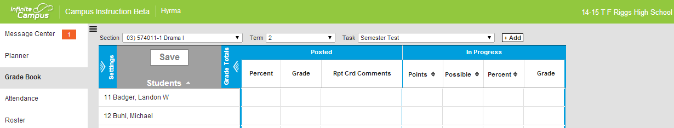

|  |  |
| --- | --- |
|  | Fill in the  Name,  Abbreviation and  Dates  Then scroll down to Scoring Alignment Detail. |
|  | Select “Semester Test” as the Grading Task.  Enter the number of total points |
|  | You can add description, objectives and references here  Click on the “***Save***” button |

## Copying Semester Test Category to other classes:

1. Click on the “***Settings***” expansion arrows: which gives you this dialog box:

|  |  |  |
| --- | --- | --- |
|  | 2. Click on the “Category Copier” menu  . | |
|  | | That will give you a screen that looks like the one on the left:  3. From the “Copy from” menu (on the left )choose a class that has the Semester Test Category that you just created.  Be sure to “unclick” the box in front of the categories that you don’t wish to copy  4. From the “Copy to” menu (On the right side) – choose the class that you would like to copy it to. (the categories that exist in that class will be listed below  5. Click the “”Next” button |

6. Click the “Copy” button.

